“Dietary & Nutrition Planner”
A Project Report Submitted in the partial fulfillment of the requirements for the award of the degree of

BACHELOR OF TECHNOLOGY
In
DEPARTMENT OF COMPUTER SCIENCE ENGINNERING
&
DEPARTMENT OF COMPUTER SCIENCE AND INFORMATION TECHNOLOGY By
E. Nakshatra : 2520030090
S.Chakrika : 2520090044

Under the Esteemed Guidance of

Dr K. Madhavi
Assistant Professor

Department of Computer Science and Engineering



K L (Deemed to be) University DEPARTMENT OF COMPUTER SCIENCE ENGINEERING
&

DEPARTMENT OF COMPUTER SCIENCE AND INFORMATION TECHNOL


Declaration
The Project Report entitled “Patient dietary profile, Meal planner, Allergy check, Calorie calc, Kitchen order, Approval flow, History, Export, Notifications, Admin panel” is a record of Bonafide work of E. Nakshatra - 2520030090 , S. Chakrika - 2520090044, submitted in partial fulfillment for the award of B. Tech in Computer Science and Engineering (or) Computer Science and Information Technology to the K L University. The results embodied in this report have not been copied from any other departments/University/Institute.
E. Nakshatra – 2520030090
S. Chakrika – 2520090044

K L (Deemed to be) University
DEPARTMENT OF COMPUTER SCIENCE ENGINEERING
&
DEPARTMENT OF COMPUTER SCIENCE AND INFORMATION TECHNOLOGY



CERTIFICATE
This is certify that the mini project based report entitled “Patient dietary profile, Meal planner, Allergy check, Calorie calc, Kitchen order, Approval flow, History, Export, Notifications, Admin panel” is a bonafide work done and submitted by E. Nakshatra - 2520030090 , S. Chakrika - 2520090044, in partial fulfillment of the requirements for the award of the degree of BACHELOR OF TECHNOLOGY in Department of Computer Science Engineering, K L (Deemed to be University), during the academic year 2025-2026.
Signature of the Guide
Signature of the Course Coordinator Signature of the HOD

ACKNOWLEDGEMENT
The success in this project would not have been possible but for the timely help and guidance rendered by many people. Our wish to express my sincere thanks to all those who has assisted us in one way or the other for the completion of my project.
Our greatest appreciation to my Course Coordinator Dr.K.Madhavi , and my guide Dr.K.Madhavi, Department of Computer Science which cannot be expressed in words for his/her tremendous support, encouragement and guidance for this project.
We express our gratitude to Dr. P Venkateshwara Roa (CSE)/Dr. Kaja Shareef (CSIT), Head of the Department for Computer Science Engineering/ Department for Computer Science and Information Technology for providing us with adequate facilities, ways and means by which we are able to complete this project-based Lab.
We thank all the members of teaching and non-teaching staff members, and also who have assisted me directly or indirectly for successful completion of this project. Finally, I sincerely thank my parents, friends and classmates for their kind help and cooperation during my work.
E. Nakshatra – 2520030090
S. Chakrika – 2520090044

Abstract
The Dietary & Nutrition Planner is an advanced full-stack healthcare application designed to automate and streamline inpatient meal management in hospitals. Standardized clinical catering often overlooks individual patient complexities; this platform bridges that gap by integrating patient health profiles with kitchen operations. The system incorporates ten core modules—including Patient Dietary Profiles, automated Allergy Checks, Calorie Calculators, and an Approval Flow for dietitians—to ensure all meals adhere strictly to therapeutic requirements and safety standards. Built using a robust full-stack architecture featuring a React.js frontend, Node.js/Express.js backend, and MySQL database storage, the application eliminates manual scheduling errors, minimizes cross-contamination risks, and optimizes institutional kitchen workflows to deliver high-quality, individualized patient care.

Index
S.  No. | Chapters | Topics | Page.no
 |  | Acknowledgement
 |  | Abstract
1 | Introduction | 1.1 Background of the project  1.2 Problem statement  1.3 Scope of the project  1.4 Objective(s)  1.5 Importance of the application  1.6 Target users/audience | 5-8
2 | System Requirements | 2.1 Hardware requirements  2.2 Software requirements  2.3 Development tools and frameworks | 8-11
3 | Technology Stack | 3.1 Front-end (e.g., React.js, Angular, HTML/CSS)  3.2 Back-end (e.g., Node.js, Django, Spring Boot)  3.3 Database (e.g., MongoDB, MySQL, PostgreSQL)  3.4 Version Control (e.g., Git, GitHub)  3.5 APIs or External services (e.g., Firebase, Stripe) | 11-15
4 | System Architecture | 4.1 High-level architecture diagram  4.2 Description of each layer (frontend, backend, database)  4.3 Deployment architecture (e.g., cloud, local, CI/CD pipelines) | 15-19
5 | Design | 5.2 ER Diagram / Database schema | 20
6 | Implementation | 6.1 Module-wise implementation  6.2 Front-end logic (UI rendering, state management)  6.3 API integration  6.4 Authentication & Authorization | 20-23
7 | Features | 7.1 List of main features  7.2 How each feature works (user perspective + technical description) | 23-27
8 | Testing | 8.1 Postman testing (frontend/backend)  8.2 Integration testing  8.3 Tools used for testing  8.4 Test cases and results | 27-30
9 | Deployment | 9.1 Steps to deploy  9.2 Environment configuration  9.3 Hosting of frontend and backend | 30-35
10 | Challenges &  Limitations | 10.1 Issues faced during development  10.2 Solutions applied  10.3 Current limitations or known bugs | 35-37
11 | Future Enhancements | 11.1 Planned features  11.2 Possible integrations or optimizations | 37-39
12 | Conclusion | 12.1 Summary of the project  12.2 What was achieved  12.3 Skills learned during development | 39-41
13 | References | - Books, tutorials, APIs, documentation sites used | 41-43

14 | Appendices | - Screenshots of the app  - Sample code snippets  - Installation/setup instructions  - User manual or guide  -Geo Tag photos with guide  -Review forms with guide signatures | 44-48

CHAPTER -1 INTRODUCTION

Background of the Project
In modern healthcare environments, clinical nutrition is increasingly recognized not merely as a supportive service, but as a core therapeutic intervention that directly influences patient recovery timelines, immune response, and overall treatment outcomes. Despite its critical importance, the dietary management infrastructure within many hospitals remains tethered to outdated, fragmented, and manual systems. Traditionally, patient dietary needs are recorded on physical charts, passed verbally during shift handovers, or transcribed across multiple non-integrated spreadsheets. This disconnected approach creates a significant operational gap between the clinical side of a hospital (doctors and dietitians) and the service side (the institutional kitchen).
As hospital facilities scale up to accommodate higher patient volumes and more specialized medical wards, the complexity of managing these dietary requirements grows exponentially. Medical conditions such as diabetes, renal failure, cardiovascular diseases, and severe gastrointestinal disorders demand strict adherence to highly specific macronutrient and micronutrient thresholds. Furthermore, institutional catering must seamlessly adapt to sudden clinical changes, such as a patient being placed on a fasting protocol (NPO) prior to surgery or transitioning from a clear liquid diet to solid foods. The Dietary & Nutrition Planner is conceptualized as an enterprise-grade, full-stack digital solution designed to bridge this communication gap. By replacing fragmented paperwork with a unified, real-time data pipeline, the platform automates the translation of clinical dietary prescriptions into accurate, actionable kitchen instructions, modernizing hospital hospitality and ensuring that nutrition aligns perfectly with patient recovery tracks.

1.2 Problem Statement
The operational disconnect between medical staff, clinical dietitians, and hospital kitchen personnel introduces severe vulnerabilities into the patient care cycle, primarily driven by human error and communication lag. Traditional manual workflows suffer from several critical points of failure:
- Fatal Allergen Oversights: Without a centralized, automated system to instantly flag ingredients, patient food allergies (e.g., peanuts, shellfish, gluten, dairy) must be cross-referenced manually against complex menu recipes. A single oversight by a busy nurse or kitchen staff member can lead to accidental allergen exposure, resulting in severe complications or life-threatening anaphylactic shock.
- Inaccurate Nutritional and Caloric Tracking: Patients suffering from critical metabolic illnesses require exact caloric distributions and strict macro/micronutrient monitoring. Calculating these requirements manually on paper charts is highly time-consuming and prone to mathematical inaccuracies, often resulting in accidental undernutrition or dangerous metabolic imbalances that delay healing.
- Logistical Latency and Food Waste: Changes to a patient’s medical status—such as unexpected discharges, room transfers, or sudden dietary modifications ordered during morning physician rounds—frequently take hours to reach the kitchen staff. This systemic delay leads to the preparation of incorrect or redundant meals, causing massive institutional food waste, inflating operational costs, and delaying meal deliveries to patients who require immediate nutritional support.

1.3 Scope of the Project
The scope of this project encompasses the complete design, full-stack development, database architecture, and end-to-end testing of a responsive, web-based software application tailored for hospital dietary management. The boundary lines of the implementation are explicitly defined as follows:
- In Scope:
  - Development of a secure multi-user authentication system supporting role-based access control (RBAC) for dietitians, kitchen staff, and admins.
  - Implementation of a dynamic patient profiling system to capture medical history, metabolic baselines, and active dietary restrictions.
  - An automated ingredient-to-allergy cross-referencing engine that screens all proposed menus before validation.
  - A calculation module to monitor daily caloric limits and nutritional breakdowns.
  - A structured, digital approval workflow requiring authorized dietitian sign-off prior to meal production.
  - A real-time kitchen dashboard that auto-generates digital preparation tickets, tracks meal completion statuses, and manages historical consumption logs.
  - Administrative utilities to update the global food/ingredient database and export data audits into downloadable reports (PDF/Excel format).
- Out of Scope:
  - Integration with external, commercial third-party food delivery networks or external public supply chains.
  - Hardware-level automation, such as controlling automated conveyor belts, robotic cooking equipment, or automated delivery rovers inside the physical hospital kitchen.

1.4 Objective(s)
The primary objectives governing the engineering and deployment of this platform include:
- Centralize and Secure Inpatient Data: To build a robust, centralized digital repository capable of securely storing, updating, and retrieving individual inpatient dietary profiles, medical conditions, and nutritional rules, eliminating fragmented spreadsheets.
- Automate Patient Safety Interventions: To implement an algorithmic safety matrix that automatically scans and cross-references food ingredients against a patient’s documented allergies, throwing immediate hard blocks to prevent the kitchen from preparing unsafe meals.
- Establish a Transparent Validation Pipeline: To design a mandatory, multi-tiered digital approval flow ensuring that every customized meal plan generated by the system is reviewed and electronically signed off by a certified dietitian or medical officer before any production order is issued to the kitchen.
- Optimize Kitchen Logistics and Workflow Efficiency: To streamline backend culinary operations by auto-translating approved nutritional prescriptions into clear, real-time, digitized kitchen preparation tickets, effectively eliminating communication lag, reducing preparation errors, and cutting down on food ingredient waste.

1.5 Importance of the Application
The implementation of the Dietary & Nutrition Planner is highly critical to modern healthcare delivery, representing a fundamental shift from reactive to proactive patient care management. From a clinical safety perspective, the application acts as a digital shield against human error; by automating allergen screening and nutritional calculation, it removes the reliance on memory or manual cross-checking, significantly reducing the liability of accidental dietary cross-contamination.
From an institutional and operational perspective, the platform drastically improves hospital efficiency. Real-time synchronization between the wards and the kitchen ensures that adjustments to dietary plans take effect instantly, preventing the preparation of cancelled or incorrect meals. This immediate updating dramatically slashes institutional food waste and lowers overhead costs. Most importantly, from a patient recovery perspective, providing precisely calibrated, targeted therapeutic diets ensures that individuals receive the exact nutritional support necessary to fuel their recovery, optimize medication efficacy, reduce hospital lengths of stay, and elevate the overall standard of clinical hospitality.

1.6 Target Users/Audience
The application is tailored to serve three primary distinct user cohorts within the healthcare facility, each interacting with a dedicated, customized interface matching their specific operational needs:
- Medical Staff & Clinical Dietitians: These are highly trained clinical users responsible for initializing patient records upon admission. They utilize the platform to input active medical diagnoses, set strict caloric parameters, run macro/micronutrient simulations, and formally approve or modify customized daily and weekly meal plans via the digital approval dashboard.
- Kitchen Operators & Culinary Staff: This cohort consists of head chefs, line cooks, and kitchen inventory managers who handle food preparation. They interact with a simplified, high-visibility real-time dashboard that displays active kitchen orders, exact ingredient breakdowns, preparation guidelines, and ward/room destination tags, allowing them to mark tickets as "In Preparation," "Ready," or "Dispatched."
- Hospital Administrators: These users have comprehensive oversight of the entire system. They use the administrative control panel to manage global master datasets (such as adding new food items or updating ingredient nutritional facts), configure role-based access permissions, add or remove staff accounts, monitor systemic audit trails for compliance, and pull global analytical reports on food utilization and kitchen efficiency.

CHAPTER -2 SYSTEM REQUIREMENTS

2.1 Hardware Requirements
To ensure a smooth environment for both the development phase and the eventual production deployment of the Dietary & Nutrition Planner, the hardware infrastructure must meet specific baselines.

A. Development Environment (Minimum & Recommended)
This specifies the machine configurations required by a developer to write code, run local servers, and test the system locally.
- Processor: Intel Core i5 (minimum) or Intel Core i7 / Apple Silicon M-Series (Recommended, 4 cores or higher).
- RAM: 8 GB RAM (minimum) to handle the code editor and backend runtime simultaneously; 16 GB RAM is highly recommended if running local relational databases and heavy browser-based testing tools (e.g., Postman and multiple browser tabs) at the same time.
- Storage: 256 GB Solid State Drive (SSD) minimum with at least 20 GB of free space. SSDs are critical to speeding up compile times and npm install package executions compared to mechanical HDDs.
- Display: Minimum resolution of $1366 \times 768$ (1080p Full HD screen recommended for testing responsive CSS layouts like Tailwind/Bootstrap side-by-side with code editors).

B. Production Deployment Environment (Hosting Server)
The cloud or on-premise infrastructure required to host the web application for the hospital network.
- Server CPU: Dual-core processor or equivalent virtual CPU (vCPU) from cloud providers (e.g., AWS EC2 t3.medium or DigitalOcean Droplet).
- Server RAM: 2 GB to 4 GB RAM minimum to run the Node.js runtime and handle active WebSocket/REST API requests concurrently.
- Network: High-speed, low-latency broadband internet connection with a dedicated static IP address to ensure reliable connectivity between hospital wards and the backend server.

2.2 Software Requirements
The application operates as a decoupled, web-accessible client-server architecture. The software components are broken down by environment layers:

A. Operating System Compatibility
- Development Platform: Windows 10/11 (64-bit), macOS (Big Sur or newer), or Linux distributions (Ubuntu 20.04 LTS or newer).
- Deployment Server: Linux-based distributions are highly preferred for hosting production Node.js instances (e.g., Ubuntu Server 22.04 LTS, Red Hat Enterprise Linux).

B. Client-Side Software (User Access)
- Web Browsers: The frontend relies on modern web standards (ES6+ features). Users require any modern web browser featuring updated V8 engines or equivalents, such as Google Chrome (v100+), Mozilla Firefox (v98+), Microsoft Edge (v100+), or Apple Safari (v15+).

C. Core Database & Runtimes
- Runtime Environment: Node.js (LTS Version 18.x or 20.x). This provides the external execution engine for compiling the frontend React application and running the backend Express server framework.
- Database Management System (DBMS): MySQL (v8.0 or higher) for structured, relational table schemas handling patient profiles, menu items, and immutable audit logs.
- State Persistence Layer: Web Browser LocalStorage API natively provided within client browsers for caching session parameters and temporary application flags.

2.3 Development Tools and Frameworks
This section highlights the technical stack, packages, libraries, and utilities engineered to build the system as referenced in your technical blueprint.

A. Core Frameworks & Structural Libraries
- Frontend Framework (React.js): A component-based JavaScript library utilized to design a single-page application (SPA). It manages rendering layers dynamically via a virtual DOM, ensuring fast UI updates without refreshing pages when a dietitian updates a plan.
- Routing (React Router Dom): Handles client-side declarative routing, dividing user segments cleanly into separate accessible paths like /admin, /kitchen, and /dietitian.
- State Management (Context API / Redux): Implemented to handle global data streams across isolated multi-step processes—such as adding a patient, assigning individual macros, running allergy algorithms, and finalizing order configurations across multiple component screens.
- Backend Server Framework (Express.js): A minimalist, flexible framework built over Node.js that enables developer-defined RESTful endpoints, custom middleware mapping (e.g., for data verification and role checks), and seamless routing.

B. Libraries & Utilities
- HTTP Client (Axios): A promise-based HTTP library used inside React to make clean asynchronous backend requests, facilitating JSON payload delivery to Express endpoints.
- Styling Toolkits (Tailwind CSS or Bootstrap 5): Pre-compiled UI utilities used to speed up user interface styling, providing pre-configured components (grids, inputs, badges, and alerts) to make dashboards responsive on both kitchen tablets and desktop monitors.

C. Supporting Tooling & Utilities
- Integrated Development Environment (IDE): Visual Studio Code (VS Code) or JetBrains WebStorm for environment management, syntactical highlighting, and code compilation.
- Package Manager (npm): Node Package Manager to install, audit, and update dependencies, project binaries, and modular libraries securely.
- API Testing Suite (Postman): A specialized desktop utility utilized during construction to formulate mock HTTP requests, validate backend payload responses, check status structures, and isolate route bugs independent of the React frontend UI.

CHAPTER-3 TECHNOLOGY STACK

3.1 Front-end (React.js, HTML5, CSS3)
The architectural blueprint of the presentation layer for the Dietary & Nutrition Planner is structured as a decoupled, high-performance Single Page Application (SPA) driven by React.js. By moving rendering logic entirely to the client web browser, the application completely eliminates traditional multi-page reload bottlenecks. This client-side agility is critical within fast-paced clinical wards and frantic kitchen workspaces where instantaneous state transitions save valuable time.
The detailed construction of this front-end layer relies on several critical structural paradigms:
- Component-Driven Modular Architecture: The user interface is completely broken down into an organized hierarchy of isolated, atomic components (e.g., PatientCard, AllergenBadge, CalorieProgressTracker, OrderTicket). Each component manages its own presentation, layout, and rendering parameters, allowing engineers to scale out visual modules cleanly without altering or endangering neighboring components.
- Advanced State Management (Context API / Redux): Managing dynamic interactions requires a reliable global data engine. When a dietitian navigates between multiple interface tabs, a unified global state manager retains the currently selected patient’s clinical metadata. This enables the core logic modules—such as the allergy check engine and the calorie calculator—to access real-time metrics seamlessly across various sub-components without triggering redundant, expensive backend API queries.
- Declarative View Routing and Guards: Client-side path resolution is explicitly managed via React Router. This engine maps browser paths cleanly into distinct user views (e.g., /admin/dashboard, /dietitian/approval, /kitchen/orders). Route guards are injected directly into the routing engine to inspect session authorization properties, preventing standard users or kitchen cooks from accessing restricted administrative operations or altering patient health data.
- Responsive Layout Layouts (Tailwind CSS / Bootstrap): Interface views are built using HTML5, CSS3, and stylized with responsive layouts. These toolkits allow data-dense grids, complex input forms, and automated alert panels to scale seamlessly across multiple device types. This guarantees optimal readability whether a physician reviews patient histories on a desktop monitor, a nurse tracks profiles on a handheld mobile device, or a chef views active orders on a wall-mounted kitchen screen.

3.2 Back-end (Node.js, Express.js)
The core application logic, data orchestration, and business rules are governed by a server application engineered over the Node.js execution runtime using the lightweight Express.js web framework. The backend functions as a secure, stateless abstraction layer bridging the gap between user interactions on the frontend and the underlying relational database.
The backend tier is divided into specific structural components:
- Asynchronous, Non-Blocking Architecture: Node’s underlying single-threaded, event-driven loop execution model is exceptionally well-suited for high-concurrency environments. As multiple hospital wards, nurses, and dietitians continuously check profiles, modify requirements, or dispatch simultaneous updates, the Express server handles these inbound requests asynchronously without choking or locking system resources.
- RESTful API Interface Design: The backend system exposes clean, standardized, stateless HTTP REST endpoints. All communication is anchored strictly on data resources, providing a structured endpoint layout:
  - GET /api/patients – Retrieves active inpatient clinical metadata.
  - POST /api/orders – Transmits a newly finalized dietary request down to the kitchen.
  - PUT /api/meals/approve/:id – Permits authorized dietitians to sign off on specific plans.
  - DELETE /api/menu/item/:id – Removes out-of-stock items from the global menu repository.
- Middleware Execution Pipeline: Express middleware acts as a sequential gatekeeper for all inbound requests. The middleware pipeline processes transactions using a clear sequence:
  - Authentication & Authorization Middlewares: Inspects data headers to verify the user's role-based access tokens before granting access to sensitive data endpoints.
  - Sanitization & Validation Middlewares: Rejects malformed payload entries (such as string inputs placed inside caloric fields or missing allergy checkboxes) before they ever reach the database.
  - Centralized Error-Handling Middleware: Catches application runtime exceptions and responds with standardized JSON error structures alongside uniform HTTP statuses ($400$ Bad Request, $401$ Unauthorized, $403$ Forbidden, $500$ Internal Server Error).

3.3 Database (MySQL)
The structural persistence, storage integrity, and historical logging of all clinical datasets are securely managed within a relational database architecture powered by MySQL. Relational database logic ensures strict compliance with ACID (Atomicity, Consistency, Isolation, Durability) principles, which is mandatory when handling sensitive patient care coordinates.
The system's database layer implements several specific features:
- Normalized Relational Schema Design: The database structure isolates discrete functional data into highly normalized data tables, minimizing storage redundancy. Tables such as patients, allergies, ingredients, meal_plans, and kitchen_orders are joined systematically via foreign key constraints. This ensures that changes to a global recipe immediately propagate across active meal tracks without requiring manual corrections across separate rows.
- Referential Integrity Constraints: The MySQL engine is explicitly configured to safeguard data against accidental destruction. Foreign key constraints dictate that an entry inside the kitchen_orders ledger cannot exist unless it is mapped directly to a valid, active identifier in the patients table. Additionally, strict update blocks prevent historical meal consumption logs from being wiped out or altered if a patient’s room assignments or current diet protocols shift during their hospital stay.
- Query Indexing and Optimization: Indexes are added to highly queried transactional parameters, such as patient_id, order_status, and allergen identification codes. This optimization guarantees that database lookup times remain sub-millisecond, allowing the kitchen dashboard to fetch and organize active prep tickers instantaneously even as the historical logs grow over years of continuous institutional use.

3.4 Version Control (Git, GitHub)
To maintain structural stability, manage code versions, and facilitate parallel feature development throughout the engineering lifecycle, the project relies entirely on distributed source code management.
The collaborative workflow relies on specific tool chains:
- Local Tracking (Git): Git is used locally on development machines to track incremental modifications within the codebase. Developers construct specialized, granular feature branches (e.g., feature/allergy-check-engine, bugfix/calorie-decimal-rounding). This design isolation keeps the primary source codebase in a deployable condition, ensuring that experimental features can be built, revised, or scrapped without breaking code branches used by other team members.
- Centralized Collaboration Platform (GitHub): GitHub serves as the remote cloud repository and project management hub. It hosts the master repository, allowing team members to sync updates, open issues, and review structural updates.
- Pull Request (PR) & Review Pipeline: Direct pushing to the production branch is strictly blocked. When a sub-module is finalized, a developer submits a formal Pull Request on GitHub. The PR undergoes code peer review and manual validation via API testing to confirm that the new frontend additions or backend database updates integrate perfectly without breaking existing endpoints or interface modules.

- 3.5 APIs or External Services (Axios, Client Storage)
The structural cohesion of the platform—binding the decoupled frontend UI components smoothly to the underlying backend logical processing cores—is enabled through a collection of integration utilities, network abstractions, and specialized service suites.
The primary operational communication vectors include:
- Asynchronous Network Transport client (Axios): The frontend React environment leverages Axios to initiate promise-based HTTP requests to the backend Express REST API. Axios interceptor modules are configured to capture outbound network transactions automatically, injecting the current user’s session authorization tokens directly into the HTTP headers to ensure security for every data exchange.
- Persistent Web Client Caching (LocalStorage): The platform utilizes the native browser-level LocalStorage API to store non-sensitive application parameters directly on user machines. It holds local user preferences, such as active navigation settings, UI display mode preferences, and temporary session expiration flags. This minimizes repetitive, unnecessary backend database configuration fetches every time a component re-renders.
- API Validation Suite (Postman): During the construction and integration phases, Postman serves as the central testing tool. It allows developers to construct, mock, and stress-test mock HTTP requests against backend endpoints before the frontend visual layout is completed. This isolates backend functionality testing from user interface bugs, ensuring that data objects match expected JSON payloads exactly.

CHAPTER -4 SYSTEM ARCHITECTURE

4.1 High-level architecture diagram
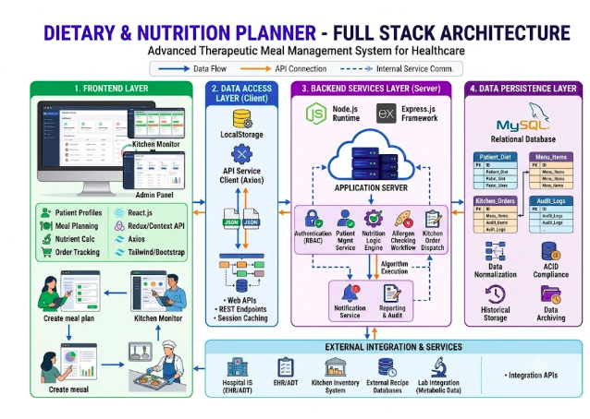

4.2 Description of Each Layer

A. Presentation Layer (Frontend)
The presentation tier serves as the visual gatekeeper and user entry point for the application. Built as a Single Page Application (SPA) using React.js, it runs completely inside the client's web browser.
- Role: It renders data-dense interfaces tailored dynamically to the authenticated user's role (Dietitian, Kitchen Staff, or Administrator).
- Mechanisms: It leverages localized component states and global stores (Context API/Redux) to manage ephemeral data (such as meal card selections) locally. Instead of forcing full-page reloads, it intercepts user actions and selectively refreshes UI fragments. It connects to the application tier asynchronously using Axios to send and receive standard JSON payloads.

B. Application Layer (Backend)
The logical brain of the application runs on a Node.js server utilizing the Express.js framework. It remains entirely stateless, relying on cryptographic tokens passed in HTTP headers to verify identity on every incoming request.
- Role: This layer processes administrative configurations, computes values, and enforces medical safety algorithms.
- Mechanisms: When a user updates a meal profile, the backend routes the request through a pipeline of sequential middleware handlers: first checking role permissions, then sanitizing data fields, and finally executing clinical checks (e.g., executing the automated Allergy Check algorithm by cross-referencing patient allergy arrays against recipe ingredient arrays).

C. Data Layer (Database)
The data tier is responsible for absolute data persistence, consistency, and safe storage of healthcare configurations. It primarily utilizes a MySQL relational database management system.
- Role: It maintains structured records of patient histories, global ingredient nutrition matrices, active kitchen orders, and immutable audit logs.
- Mechanisms: It uses structured foreign-key relationships to preserve referential integrity, blocking dangerous deletions (e.g., ensuring a meal plan cannot be orphaned if its patient record is updated). In tandem with MySQL, browser-level LocalStorage is utilized as a minor, secondary client-side sub-layer to temporarily cache static interface preferences.

4.3 Deployment Architecture

A. Environment Infrastructure Hosting
The application is designed to be deployed using modern virtualized server architectures. Depending on hospital policy, this can be implemented via Cloud Hosting (e.g., Amazon Web Services (AWS) EC2 or DigitalOcean Droplets) or on an On-Premise Local Server within the hospital's private intranet for heightened data privacy.
- Frontend Web Server: The compiled static React assets (HTML, CSS, JavaScript bundled via npm production scripts) are hosted and served via a high-performance web server or Content Delivery Network (CDN) such as Nginx or AWS S3. Nginx efficiently handles inbound web requests and acts as a reverse proxy.
- Backend Application Server: The Node.js application process runs continually in the background, supervised by a process manager like PM2. PM2 monitors server health, auto-restarts the node process if an unexpected exception occurs, and handles load balancing across multiple CPU cores.
- Database Instance: The MySQL engine runs on a isolated, protected sub-network or a managed instance, allowing database accessibility only via connections emanating from the backend Express server's static IP address.

B. CI/CD (Continuous Integration / Continuous Deployment) Pipeline
To ensure zero-downtime updates and seamless integration of new code modifications, a systematic automated delivery pipeline is structured using GitHub Actions: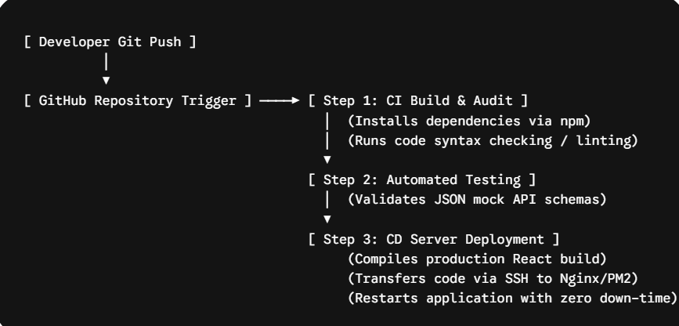
- Continuous Integration (CI): Every time code is successfully reviewed and merged into the main GitHub branch, a GitHub Actions runner instantiates an automated build sandbox. It runs npm install to check for dependency breaks and runs linting checks to ensure code compliance.
- Continuous Deployment (CD): Once the build steps validate successfully without errors, the automated runner handles deployment. It compiles the optimized production build of the React frontend, establishes a secure SSH shell tunnel to the host environment, pushes the new code updates, and commands PM2 to perform a graceful reload of the backend application—ensuring hospital staff experience uninterrupted access to the platform.

CHAPTER -5 DESIGN

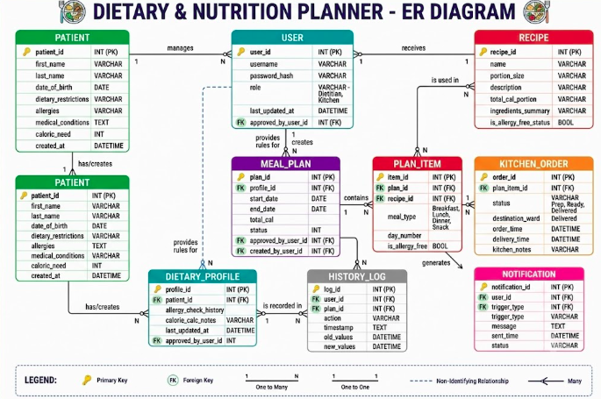

CHAPTER -6 IMPLEMENTATION

6.1 Module-Wise Implementation
The application is engineered around isolated, functional sub-modules running across both the client interface and the backend server. The detailed behavioral mechanics for your modules are defined as follows:
- Patient Dietary Profile: Provides CRUD (Create, Read, Update, Delete) database management engines. Upon admission, staff register demographic metrics, active pathological diagnoses (e.g., Type-2 Diabetes, Chronic Kidney Disease), and historical constraints.
- Meal Planner: A timeline construction module enabling dietitians to map menu options into standard dynamic meal slots (Breakfast, Lunch, Dinner, Snack) across daily or weekly schedules.
- Allergy Check Engine: An algorithmic safety barrier executing on the server. When a meal plan is configured, the module intercepts the plan item, pulls the corresponding component ingredients from the recipe database, and performs an explicit array intersection check against the patient's active allergen keys. If a clash matches, it flags a hard system block.
- Calorie Calculator: Calculates and dynamically updates daily caloric thresholds and macronutrient goals ($Protein$, $Carbohydrates$, $Fats$) based on a patient's clinical baseline.
- Kitchen Order Management: Extracts approved meal plans and transforms them into active line-item kitchen records, tracking status variables precisely (Pending $\rightarrow$ In Preparation $\rightarrow$ Ready for Dispatch $\rightarrow$ Delivered).
- Approval Flow Middleware: Implements status locks on modified or newly drafted dietary schedules. These tracks are saved with an Is_Approved = FALSE state flag, preventing them from transferring down to active kitchen queues until a user possessing a Dietitian role submits an approval transaction.
- History & Logging Ledger: An immutable tracking data vault that records past patient profile states, modified meal selections, and dietitian revisions to provide institutional accountability.
- Data Export Service: Client-side drivers that compile localized application states or clinical histories, generating formatted tables using export libraries to produce downloadable PDF or Excel documents for patient discharge files.
- Notifications Engine: An interactive internal notification layer that triggers real-time alerts on dashboards when kitchen meals are finished, critical ingredient shortages arise, or emergency diet rewrites are ordered.
- Admin Control Panel: Provides superuser dashboards to manage global structural lookup assets, manipulate user access roles, append items to the global food database, and view hospital ward utilization metrics.

- 6.2 Front-End Logic (UI Rendering & State Management)
The React client application runs completely inside user web browsers and operates on a decoupled rendering lifecycle:
- Dynamic Component Rendering: UI views adapt in real time to state changes. For example, the CalorieProgressTracker uses standard math components to instantly re-render progress meters as items are added to a meal plan, without requiring full page refreshes.
- Global State Management (Context API / Redux): Ephemeral tracking data—such as the currently active patient context or modified recipe profiles—is placed in a globally accessible store. This prevents "prop drilling" and allows separate UI components (e.g., an allergen alert badge in the header and an ingredient table in the main panel) to react instantly to the same user action.
- Local Caching (LocalStorage): Web browser LocalStorage acts as an explicit client cache. It retains the user’s cryptographically signed session token and static UI settings, enabling seamless page navigation without losing session continuity.

6.3 API Integration
Data transport between the client React SPA and the backend Express server relies on automated, stateless asynchronous network bridges.
[ React UI Component Action ]
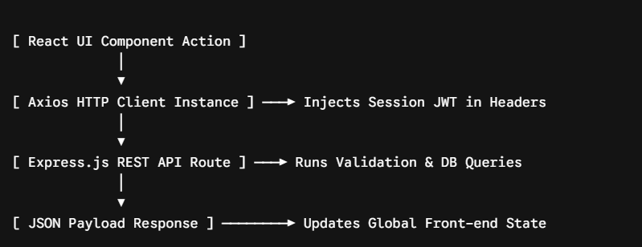 Response ] ────────► Updates Global Front-end State
- Asynchronous Communication (Axios Client): The application integrates Axios to execute promise-based asynchronous requests. This decouples user interface interactions from network latency, enabling a smooth user experience while data fetches process in the background.
- Standardized REST Endpoints: Communication structures align with uniform REST architectural standards. JSON objects serve as the exclusive transport format for both input payloads and backend database query responses.
- Request Interceptors: Custom Axios instances deploy request interceptors to automatically catch outgoing calls and append the active session's authentication token to the HTTP Authorization: Bearer <Token> header. This secures the endpoint without requiring developers to manually write token attachment routines for every single API fetch.

6.4 Authentication & Authorization
System security and data access constraints are enforced using industry-standard JSON Web Tokens (JWT) and Role-Based Access Control (RBAC) mechanisms.
- User Authentication Lifecycle: When a hospital user logs into the system, the Express backend verifies the credentials against the hashed values in the MySQL database. Upon confirmation, the server generates a cryptographically signed, time-bound JWT payload containing the user's identification keys and system role, returning it to the client browser.
- Role-Based Access Control (RBAC): Backend Express routes are wrapped in security middleware functions that decode incoming JWT sub-properties. If a kitchen user attempts to call an endpoint locked behind a dietitian permission gate (e.g., PUT /api/meals/approve/:id), the route handler intercepts the transaction and returns an explicit $403\text{ Forbidden}$ status code, preventing unauthorized data modifications.

CHAPTER 7- FEATURES
Here is the extensive functional documentation for Chapter 7: System Features & Operational Workflows, outlining your application from both the end-user's viewport and the underlying technical execution layer.

7.1 List of Main Features
The Dietary & Nutrition Planner consolidates its core requirements into ten user-facing features, engineered to eliminate manual healthcare oversights:
- Inpatient Dietary Profiling Engine
- Dynamic Interactive Meal Scheduler
- Algorithmic Allergen Cross-Checking & Safety Lock
- Real-time Macronutrient & Calorie Progress Calculator
- Digital Kitchen Order Routing & Ticket Lifecycle System
- Dietitian Peer-Review & Validation Approval Flow
- Immutable System Change History & Clinical Logging Audit
- On-Demand Report Compilation & Data Export Dashboard
- Real-Time Event Notification & Broadcast System
- Global Administrative Configuration & Data Control Center

7.2 Detailed Feature Workflows

1. Inpatient Dietary Profiling Engine
- User Perspective: Upon admission, a nurse or clinical clerk opens the patient profile portal. They fill out a structured digital intake sheet containing the patient's name, ward location, active medical diagnoses (e.g., chronic kidney disease, gestational diabetes), and a checklist of known food allergies. Once saved, this data serves as the baseline for all future meal plans.
- Technical Description: The frontend captures form inputs and transmits a structured POST JSON request via Axios to /api/patients. The Express application intercepts the payload, applies schema validation middleware to prevent corrupted inputs, and runs a structured INSERT INTO patients ... query within the MySQL database, assigning a permanent indexed patient_id key.

2. Dynamic Interactive Meal Scheduler
- User Perspective: A dietitian logs in, selects a patient card, and opens a calendar-style dashboard. They can select predefined, dietitian-approved meal recipes from a drop-down menu and drag or drop them into designated slots: Breakfast, Lunch, Dinner, or Snack for an individual day or a full weekly rotation.
- Technical Description: The React interface tracks the layout state through local component states and global Redux hooks. When a menu item is assigned to a slot, an item object mapping the patient_id, recipe_id, meal_type (e.g., Lunch), and target day_number is dispatched to the backend via POST /api/meal-plans. This triggers row additions to the plan_item table in MySQL.

3. Algorithmic Allergen Cross-Checking & Safety Lock
- User Perspective: If a user accidentally adds a menu item containing an ingredient that conflicts with a patient's documented allergies (e.g., placing peanut butter oatmeal onto the tray of a patient with a severe peanut allergy), the interface immediately flashes a high-visibility red warning banner, blocks the selection, and prevents the plan from saving.
- Technical Description: When a plan is submitted, the backend routes the transaction through an automatic interception function. It fetches the patient's allergy array (SELECT allergy_id FROM patient_allergies WHERE patient_id = ?) and executes an array intersection comparison with the selected recipe's composition array (SELECT ingredient_id FROM recipe_ingredients WHERE recipe_id = ?). If an overlap is discovered, the server terminates the process, throws an algorithmic alert, and returns a $400\text{ Bad Request}$ response code accompanied by an explicit allergen warning message string.

4. Real-time Macronutrient & Calorie Progress Calculator
- User Perspective: As a dietitian constructs a daily food rotation, interactive bar meters at the top of the interface screen adjust in real time. These meters visualize the total accumulative calories, proteins, carbohydrates, and lipids of the chosen plan, filling up against the patient's target maximum threshold limits.
- Technical Description: Each recipe row in the database contains structured numeric properties for macro profiles. React uses array math functions (e.g., .reduce()) to calculate values on the client side:
$$\text{Total Caloric Subtotal} = \sum (\text{Portion Size} \times \text{Recipe Base Calories})$$
This calculation executes instantly on every state modification, bypassing unnecessary network delays and providing immediate visual feedback before final database submission.

5. Digital Kitchen Order Routing & Ticket Lifecycle System
- User Perspective: Kitchen personnel view a simplified, large-format interface screen mounted inside the preparation area. When a meal plan is fully validated, a new prep card automatically populates on their screen detailing the menu name, exact kitchen ingredients, specific preparation notes, and the delivery destination. Cooks click simple interactive action badges to advance the order lifecycle status flags from Prep to Ready to Delivered.
- Technical Description: Kitchen order tickets are tracked within the kitchen_orders MySQL table using defined status enumeration values (ENUM). When culinary staff click an interaction trigger, an Axios network handshake fires a PUT /api/orders/status/:id token transaction, which fires a fast relational transaction (UPDATE kitchen_orders SET status = 'Ready' WHERE order_id = ?), dynamically changing the dashboard card state across active client screens.

6. Dietitian Peer-Review & Validation Approval Flow
- User Perspective: When junior kitchen assistants or nursing students modify a plan, the meal sequence enters a greyed-out "Pending Approval" state. The ticket remains locked and invisible to the kitchen monitors until an authorized head dietitian reviews the file and clicks an orange "Approve Plan" key.
- Technical Description: The system enforces a strict schema field constraint (is_approved TINYINT DEFAULT 0). Kitchen retrieval operations filter data queries exclusively on approved states (SELECT * FROM kitchen_orders WHERE is_approved = 1). The approval command relies on RBAC backend path validation middleware; the server decodes the operator's JWT payload and signs off on the record only if the role property validates as Dietitian.

7. Immutable System Change History & Clinical Logging Audit
- User Perspective: Administrators can view an audit ledger showing every modification made to a patient's diet history. The dashboard displays the exact timestamp, the operator name, and a clear comparison of what specific details were altered.
- Technical Description: The backend implements an event logging utility. Any path handling mutations (POST, PUT, DELETE) triggers a secondary database execution inside the Express router code. This automatically pushes contextual event data into the history_log audit table using fields like user_id, action_type, old_values, and new_values.

8. On-Demand Report Compilation & Data Export Dashboard
- User Perspective: Users can click a "Download Audit PDF" or "Export Excel" button on a patient's historical profile page to instantly download a neatly arranged corporate spreadsheet or medical record document suitable for clinical reviews or discharge paperwork.
- Technical Description: The client interface isolates the specific object array from the active React application state. It passes the structured array through localized compilation scripts (such as data-table mapping wrappers), which generate a clean, un-stylized data blob directly inside the user's browser, prompting an automatic file-save download sequence without creating server overhead.

9. Real-Time Event Notification & Broadcast System
- User Perspective: The moment the kitchen flags an order as "Ready for Dispatch," a green notification alert badge drops down on the ward nurse's terminal screen, ensuring that therapeutic meals are picked up and delivered while fresh.
- Technical Description: The application tier handles real-time alerts through persistent client-server polling intervals or transactional hooks inside the database execution routes. When an order update runs successfully, the backend returns a success flag that updates the local dashboard states, immediately triggering UI state re-renders across connected terminals.

10. Global Administrative Configuration & Data Control Center
- User Perspective: Administrative personnel use a closed, protected master workspace panel to register new employees, modify role access tokens, add brand new ingredients to the master ingredient list, or update basic room and ward counts as the facility scales out.
- Technical Description: A highly secure administrative sub-router controls access to these paths, protected by explicit middleware that matches requests against user role keys (role == 'Admin'). The user interface utilizes responsive layout arrays and form grids to present clean data input templates for rapid master-data entry and system configurations.

CHAPTER -8 TESTING

8.1 Postman Testing (Frontend/Backend)
Because the application relies entirely on a decoupled client-server architecture, Postman was utilized to run isolated backend API tests prior to full frontend integration. This ensured that data mutations, validation constraints, and security middleware were completely operational independent of the user interface.
- Endpoint Integrity Testing: Every REST endpoint route was mapped into a dedicated Postman Collection. Developers ran structured test scripts to verify that parameters sent via JSON body inputs (e.g., creating a new patient record or submitting a meal order) returned the exact expected HTTP response status keys ($201\text{ Created}$ or $200\text{ OK}$).
- Response Schema Validation: JavaScript assertion routines were configured within Postman's "Tests" tab to evaluate the structural topology of returning JSON objects. These routines ensured that properties such as data types (e.g., verifying total_cal is a number) and structured nested arrays matched specifications exactly.
- Security Token Simulation: To test the Role-Based Access Control (RBAC) layers, Postman collection variables were configured to save a JWT access token automatically upon a successful /api/auth/login request. This token was then dynamically injected into the Authorization: Bearer <JWT> header of subsequent endpoints, confirming that unauthorized role keys successfully triggered a $403\text{ Forbidden}$ block.

8.2 Integration Testing
Integration testing verified that data pipelines flowed smoothly across the presentation, logic, and data tiers without breaking structural boundaries.
- Frontend-to-Backend Connection: Verified that asynchronous network transactions triggered via Axios on the React frontend cleanly hit Express.js endpoint middleware routers, handled the request, and returned uniform data payloads safely back to the client interface state handlers.
- Backend-to-Database Integrity: Confirmed that data entities passing validation criteria were accurately processed by the relational database layer. For example, testing checked that writing a record to plan_item successfully pulled foreign key dependencies from the recipes and meal_plans tables while strictly rejecting orphaned data structures.
- Algorithmic Engine Pipeline Validation: Tested the explicit operational intersection loop of the Allergy Check Engine. The integration test manually pushed a food recipe containing a simulated allergen directly into a patient profile containing a matching allergy flag. The tracking system verified that the algorithm correctly detected the conflict, rolled back the pending transaction to keep the database clean, and delivered an error status smoothly back to the client UI.

8.3 Tools Used for Testing
The test layout was executed using a specialized suite of system optimization, diagnostic, and interface-monitoring tools:
- Postman Desktop App & CLI: The primary tool for mocking, executing, and grouping asynchronous backend HTTP REST API calls, validating JSON responses, and running script arrays.
- Web Browser Developer Controls (Chrome DevTools): Used to audit frontend operations. The Network panel monitored underlying network latency and Axios payloads, while the Application panel confirmed that time-bound session variables inside LocalStorage were safely reading, updating, and clearing upon logout.
- MySQL Workbench / Command Tooling: Used to monitor target data tables directly, running raw verification queries to ensure that mutations matched expectations and that table indexes speed up search lookups under stress.
- Console Logging Drivers: Integrated within Node.js middleware logic using targeted output logging to print active processing loops, data states, and runtime error stacks onto terminal displays during local execution phases.

8.4 Test Cases and Results
The core functional vectors of the platform were evaluated using formal black-box and white-box test cases. The resulting matrices are documented below:

Test Suite Ledger & Evaluation Matrix
Test ID | Feature Covered | Test Scenario Description | Input Variables Provided | Expected System Response | Observed Result State | Pass/Fail
TC-001 | Authentication | Attempt portal login using invalid account credentials. | username: "wrong_user", password: "123" | Server returns $401\text{ Unauthorized}$ with an error string; client blocks access. | $401\text{ Unauthorized}$ received; login screen flashed validation message. | PASSED
TC-002 | Authentication | Access a dietitian-locked path with a lower-tier role. | Route: /api/meals/approve, Token Role: "Kitchen_Staff" | Server returns $403\text{ Forbidden}$ and blocks the transaction. | Request intercepted by RBAC middleware; returns $403$ status. | PASSED
TC-003 | Patient Profile | Register a new inpatient profile with valid records. | JSON body payload with full name, ward name, and allergy string arrays. | Data added to MySQL with an autogenerated ID; returns $201\text{ Created}$. | Database updated with unique record ID; returns status $201$. | PASSED
TC-004 | Allergy Check | Add a recipe containing an allergen to a restricted patient plan. | patient_id: 12 (Allergic: Nuts), recipe_id: 45 (Contains: Peanut Butter) | Algorithm flags conflict, blocks database commit, and returns status $400$. | Transaction intercepted; red alert bar displayed on UI; status $400$ returned. | PASSED
TC-005 | Calorie Calc | Add menu items to a daily meal track layout. | Meal 1: 450 kcal, Meal 2: 600 kcal | Client UI runs math calculation to render a subtotal sum of $1050\text{ kcal}$. | Progress trackers automatically adjusted to reflect $1050\text{ kcal}$ instantly. | PASSED
TC-006 | Approval Flow | Retrieve active kitchen tickets before a dietitian provides approval. | Query: GET /api/orders, Target target state flag: is_approved = 0 | The endpoint payload array excludes the unverified meal plan entry. | Unapproved orders remained hidden from kitchen displays; status $200$. | PASSED
TC-007 | Kitchen Order | Transition a cooking order state badge. | Trigger click on prep ticket, updating status value path to 'Ready'. | Database updates record row attribute; UI shifts card to the correct view tab. | ENUM field updated in MySQL; status card moved to "Ready" panel in real time. | PASSED

CHAPTER -9 DEPLOYMENT

9.1 Steps to Deploy
Deploying a decoupled, enterprise-grade Three-Tier architecture into a live healthcare facility demands a systematic approach to eliminate data disruption and ensure strict alignment with the application's design principles. The process is executed across four main operational deployment phases:
- Code Optimization and Asset Bundling
Before code leaves the local engineering environment, it must be prepared for production handling. In the root folder of the React single-page application, development scripts are terminated, and a formal build compilation command is executed:
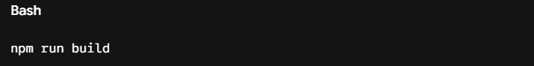
run build
This script initiates a production-level compilation engine that strips out all developer-facing utilities, removes testing hooks, and compresses Javascript, HTML5, and CSS3 assets into minified, highly dense files housed inside an immutable static /build or /dist output directory.
- Database Instance Initialization
The production database engine must mirror the schema design specified in the entity-relationship diagrams exactly. The administrator logs into the target hosting machine's MySQL terminal and loads the schema definition files. This execution builds the normalized, primary-keyed relational table infrastructures (patients, users, meal_plans, recipes, kitchen_orders, dietary_profile, plan_item, history_log, notification), creates the database connection pool limits, and enforces relational foreign key constraints to prevent orphaned operational records.
- Application Runtime Preparation
The production backend server is built upon a clean Linux operating system installation (such as Ubuntu Server 22.04 LTS). The environment is initialized with Node.js and its corresponding node package manager binaries. The production codebase is pulled via secure version-control pipelines directly from the master repository branch. The system engineer navigates to the backend directory and executes the isolated dependency command:

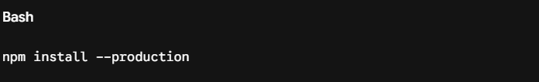 install --pr
This ensures that testing tools or developer dependencies are completely omitted from the active production runtime, reducing the server attack surface and optimizing resource usage.
- Reverse Proxy Configuration and Service Activation
To ensure outside traffic can safely reach the application without exposing internal application ports directly to the web, a high-performance web server (such as Nginx) is installed. The Nginx server block files are configured to serve the static frontend assets directly and route incoming API data endpoints down to the protected running application processes. Once verified, the process orchestrator is triggered to set the entire system live with zero downtime.

9.2 Environment Configuration
To preserve system architecture boundaries, ensure security compliance, and isolate testing parameters from real-world medical workflows, the Dietary & Nutrition Planner strictly isolates its configuration properties from the functional application logic. All critical system keys, communication ports, and access credentials are kept external to the code repository, loaded dynamically via localized environment files (.env).

A. Primary Backend Configuration Architecture (backend/.env)
The application backend file is placed directly onto the host server and contains the specific parameters necessary to establish database access tunnels, listen for client connections, and handle token encryption:# Host Server Network Allocation
PORT=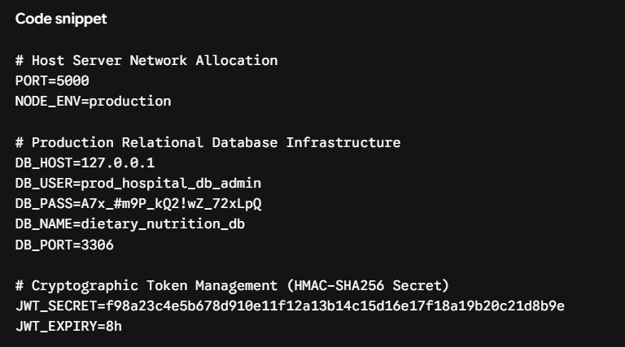

B.Frontend Production Endpoint Pointer (frontend/.env.production)
The client-side single-page application requires an explicit build-time pointer to identify where to route network requests initiated via Axios, avoiding manual configuration changes across development cycles:
Code snippet
# Asynchronous REST API Destination Gateway
REACT_APP_API_BASE_URL=https://api.hospitalnutritionplanner.com/api
⚠️ Mandatory Operational Security Note: Both the frontend and backend environment configurations are explicitly cataloged within the project’s .gitignore rules. This precaution prevents hardcoded credentials or system secrets from ever being leaked or committed to source-control tracking histories on GitHub.

9.3 Hosting of Frontend and Backend
The operational efficiency of the system depends on an architecture where the user-facing presentation layer and the resource-intensive backend logic layer are hosted as independent subsystems. This division allows the platform to balance computing resources effectively under heavy multi-ward hospital workloads.
+-----------------------------------------------------------------------------------+
| USER BROWSER |

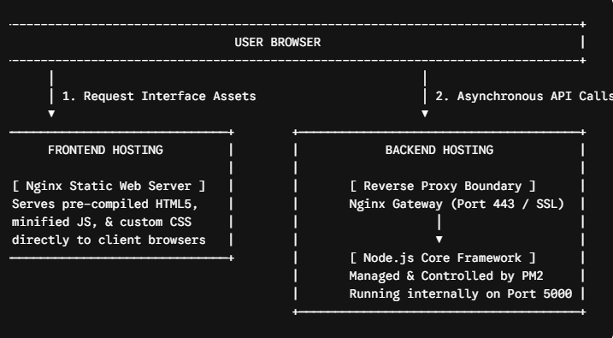

1. Frontend Hosting Architecture (Static Web Asset Engine)
- Operational Execution Mode: The front-end React application is entirely static after compilation. Because it does not require a live, continuous server-side engine to build pages dynamically, it is hosted via an Nginx Web Server.
- Behavioral Mechanism: When an authorized hospital user inputs the system's URL into their browser, Nginx bypasses processing layers and instantly serves the pre-compiled, static HTML, CSS, and minified JavaScript assets straight to the client device. The browser receives this data package and executes all rendering logic, page transitions, and interface updates locally using the client machine's memory, reducing unnecessary load on the server.

2. Backend Hosting Architecture (Node.js & PM2 Ecosystem)
- Operational Execution Mode: The logical application tier runs continuously in the background as an active Node.js server instance. It handles heavy operations, evaluates database transactions, and manages API requests.
- Process Monitor Integration (PM2): To ensure maximum reliability and automated recovery within mission-critical medical environments, the production backend service is managed by the PM2 Process Manager. PM2 provides structural system stability through several automated mechanisms:
  - System Resilience: It monitors application health and automatically restarts the Node server if an unhandled runtime error causes a programmatic crash.
  - Autoboot Execution: It scripts itself into the host operating system's startup logs to ensure the system automatically reboots if the physical machine experiences an unexpected power cycle.
  - Clustered Load Balancing: It spawns multiple instances of the application backend code across separate internal CPU threads, distributing incoming connection loads evenly to prevent system latency.
- Reverse Proxy Protection Layer: Nginx is positioned directly in front of the application server to serve as an administrative Reverse Proxy Gateway. Outside user machines never interact with or make network calls directly to the internal application port $5000$. Instead, Nginx receives all inbound queries over port $443$, decrypts the SSL/TLS security certificate wrappers, runs structural header checks, and seamlessly forwards the clean traffic down to the localized application threads running safely on the internal server.

CHAPTER -10 CHALLENGES & LIMITATIONS

10.1 Issues Faced During Development
Building a decoupled, full-stack medical application presented complex challenges across state synchronization, algorithmic data structures, and systemic data security:
- Asynchronous Serialization and Data Race Conditions: During intensive frontend interaction testing, multi-layered components (such as updating a meal item while the progress trackers recalculated totals) caused severe state synchronization lag. Because multiple Axios calls were resolving out of chronological order, the global React Context store frequently mapped older database responses over newer client edits. This led to discrepancies where the UI parameters did not match the backend data models.
- Algorithmic Matrix Overhead in Allergen Verification: Initially, the allergen cross-checking logic relied on nested client-side iteration loops to evaluate proposed menu arrays against complex patient restriction profiles. As the global ingredients database scaled up, this approach created massive rendering delays in the browser UI, causing brief interface locks.
- Relational Database Anomalies and Cascading Depletions: Designing the MySQL table architecture without strict execution controls led to referential integrity issues. During initial integration, updating a standard recipe profile or wiping out an inactive staff identity code accidentally triggered broad cascading deletions across historical ledgers, corrupting old clinical logs.
- JWT Token Persistence Across Re-renders: A recurring vulnerability occurred when state updates or hard browser manual refreshes abruptly flushed the volatile React memory space. This completely dropped the active cryptographic access tokens and logged hospital users out mid-transaction during critical dietary configurations.

10.2 Solutions Applied
To address these technical hurdles, the following architectural solutions were designed and implemented:
- Centralized State Standardization and Request Throttling: To resolve data race conditions, the frontend data layer was refactored. Network handshakes were standardized using explicit async/await chains, and request throttle structures were added to block rapid, overlapping database edits. This ensured that the global React store updated only after a clean database acknowledgment signal.
- Backend Algorithmic Acceleration and Database Interception: The responsibility for allergen checking was shifted completely off the client-side presentation layer. It was reconstructed as a focused database query constraint using indexed MySQL table cross-references:
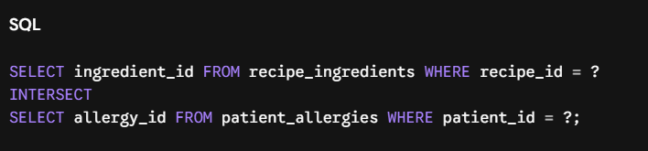
Moving this array evaluation to indexed database tables reduced processing overhead down to sub-millisecond timelines, keeping the frontend fluid.
- Referential Integrity Constraints and Soft-Delete Flags: The MySQL schema properties were hardened by replacing standard destructive CASCADE rules with structural RESTRICT and SET NULL foreign key configurations. Additionally, a logical is_active TINYINT DEFAULT 1 soft-delete matrix column was injected into master lookup templates. This allowed data items to be cleanly hidden from active front-end drop-downs while protecting and preserving past clinical entries intact.
- Persistent Web Storage Token Injections: To maintain continuous application runtime state, the authentication pipeline was re-engineered. Upon credential verification, the system securely mirrors time-bound JSON Web Tokens inside the web browser's native LocalStorage API. Custom Axios request interceptors were integrated to dynamically extract and bind this persistent string directly to the header values of every outgoing network transport call:
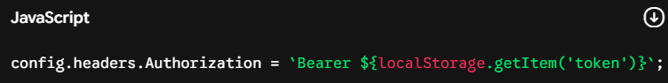 `;

10.3 Current Limitations or Known Bugs
While the application functions reliably across its ten core modules, the system operates under certain architectural boundaries and known edge-case conditions that represent opportunities for future optimization:
- Lack of Real-Time Bi-Directional WebSocket Syncing: The notification and messaging system currently operates on client-initiated refresh intervals and HTTP polling requests rather than persistent bi-directional WebSocket pipelines. Consequently, if a nurse switches order statuses, the change updates immediately on their terminal, but kitchen operators experience a brief delay before their interface syncs, unless they manually refresh the active tab.
- Volatile Client-Side State Cache Clearances: Because the active session keys rely on browser LocalStorage for quick access persistence, manually clearing the browser cache or accessing the app via a temporary Incognito instance completely flushes the runtime parameters, resulting in an abrupt session termination.
- Static Macro Evaluation Limits: The calorie calculation matrix performs operations strictly assuming a fixed 100% preparation yield weight. The algorithm cannot currently account for precise culinary real-world variables, such as moisture loss during cooking or plate waste leftovers, which means the calculated metrics represent the served nutrient profiles rather than exact consumed values.
- Absence of External Electronic Health Record (EHR) Syncing: The architecture operates as an independent, self-contained health system silo. It requires manual profile initialization by hospital staff because it lacks direct integration adapters to automatically stream patient data from global hospital infrastructure networks (like HL7 or FHIR protocols).

CHAPTER -11 FUTURE ENHANCEMENTS

11.1 Planned features
The system will implement the following core features distributed across the 10 mandatory modules to ensure a seamless, secure, and efficient inpatient meal planning experience:
- Patient Dietary Profile: A comprehensive dashboard to log and manage patient details, focusing on medical conditions, specific dietary restrictions (e.g., vegan, diabetic, low-sodium), and critical allergies.
- Meal Planner: A dynamic, calendar-based interface allowing nutritionists to design daily or weekly menus tailored to individual patient profiles.
- Automated Allergy Check: A cross-referencing system that automatically flags and blocks any meal assignments containing ingredients that conflict with a patient's logged allergies or medical conditions.
- Calorie Calculator: A real-time calculator that aggregates macronutrients and total caloric values as meals are built, ensuring they hit the exact target requirements of the patient.
- Kitchen Order Management: A direct transmission pipeline that converts finalized meal plans into actionable kitchen orders, tracking preparation status (e.g., Pending, In Preparation, Out for Delivery).
- Multi-Level Approval Flow: A verification workflow where meal plans created by assistant staff must be reviewed and digitally approved by a head dietitian or medical officer before being pushed to the kitchen.
- Meal History Log: A detailed historical archive of all past meals served to a patient, along with caloric consumption trends and any recorded adverse reactions.
- Report Export Utility: A feature allowing administrators and medical staff to export patient nutritional summaries, billing details, or daily kitchen tallies into PDF or Excel formats.
- Real-Time Notifications: Live alert systems (using toast notifications or webhooks) to notify nursing staff of pending approvals, and kitchen staff of urgent dietary updates or room changes.
- Admin Panel: A centralized control center for managing user roles (Admin, Dietitian, Kitchen Staff, Nurse), updating the global food/ingredient database, and managing system configurations.

11.2 Possible integrations or optimizations
To elevate the application from its baseline architecture to a production-grade healthcare system, the following technical optimizations and third-party integrations are planned:

Technical Optimizations
- Debounced Real-Time Calculations: Implement debouncing on the frontend calorie calculator to minimize UI re-renders and reduce processing overhead when adjusting complex meal portions.
- Smart LocalStorage Syncing: Use LocalStorage to cache the global ingredients database and common meal templates on the client side, significantly dropping API fetch frequencies and speeding up menu creation.
- Optimized Database Schema: If utilizing MySQL, establish explicit indexing on patient IDs and allergen foreign keys to ensure the critical "Allergy Check" query runs in milliseconds, even under high database loads.

Future Integrations
- HL7 / FHIR EMR Integration: Integrate with standard Electronic Health Record (EHR) systems to automatically pull patient admissions, room numbers, and medical diagnoses, eliminating manual entry errors.
- Nutritional API Integration: Connect the system with verified external food databases (such as the USDA FoodData Central API) to instantly source accurate, up-to-date micro and macronutrient breakdowns for raw ingredients.
- Kitchen Display System (KDS): Integrate with physical touchscreens or ticket printers in the hospital kitchen to replace paper workflows with real-time digital order queues.

CHAPTER – 12 CONCLUSION

12.1 Summary of the Project
The Dietary & Nutrition Planner is an advanced, full-stack healthcare application designed to streamline and automate inpatient meal planning within hospital environments. Developed as a safety-critical system, the application bridges the gap between clinical patient data and food service operations.
The core purpose of the system is to dynamically generate customized meal plans tailored to each patient's specific medical conditions, allergies, dietary restrictions, and daily caloric requirements. By integrating a multi-step clinical approval workflow, the platform ensures that no meal reaches a patient without meeting strict medical safety benchmarks. Once approved, the system directly digitizes kitchen orders, tracks historical meal data, and provides administrators with an analytical panel to oversee hospital-wide nutritional operations.

12.2 What Was Achieved
During the development lifecycle, a robust, responsive web application was built from the ground up, successfully implementing all 10 core functional modules:
- Patient Dietary Profiling & Calorie Calculation: Developed an intake system to log medical histories, allergies, and restrictions, backed by a dynamic engine that automatically calculates daily target caloric and macronutrient thresholds.
- Intelligent Meal Planning & Safety Verification: Built an interactive meal scheduling system equipped with an automated Allergy Check algorithm that flags and blocks food items containing contraindicated ingredients.
- Operational Kitchen & Approval Workflows: Designed a structured multi-tier approval pipeline allowing healthcare professionals to review, modify, or sign off on meal plans, which instantly updates the real-time Kitchen Order tracking queue.
- Data Auditability & Export Capabilities: Implemented an immutable meal history log alongside data compilation tools, enabling staff to export nutritional records and diet summaries for official medical archiving.
- System Administration & Communications Hub: Created a central Admin Panel for managing system configurations, dietary databases, and user roles, supported by an in-app notification system to alert staff of sudden diet updates or critical kitchen changes.
- Full-Stack Architecture Integration: Built and connected a decoupled architecture using a React.js frontend and a Node.js/Express.js backend, utilizing REST APIs and Axios for smooth, asynchronous state management and data delivery.
12.3 Skills Learned During Development
The execution of this advanced project provided deep technical growth and domain-specific insights, particularly in the following areas:

Technical & Engineering Skills
- Advanced React State Management: Gained expertise in handling complex, global data states (such as active patient profiles, pending kitchen queues, and shopping baskets) using Context API / Redux.
- RESTful API Design & Testing: Mastered the process of architecting modular backend endpoints with Express.js, validating data payloads, and rigorously debugging edge cases utilizing Postman.
- Robust Client-Side Performance: Learned to optimize data persistence and user sessions through strategic use of LocalStorage, while managing clean browser histories and page access controls via React Router.
- Modern UI/UX Frameworks: Enhanced styling and responsive design workflows by leveraging modern component libraries (Bootstrap / Tailwind CSS) to ensure the dashboard remains highly readable and operational on both desktop workstations and kitchen tablets.

Domain-Specific & Professional Growth
- Healthcare Workflow Logic: Developed a practical understanding of clinical software design rules, specifically focusing on data validation, cross-contamination prevention, and safety-critical approval gates.
- Full-Stack Lifecycle Management: Strengthened end-to-end software development skills, ranging from project initialization and package management with npm, up to structured backend schema planning.

CHAPTER 13 : REFERENCES

Official Documentation Sites
To build a clean, production-ready architecture, always rely on the official docs for your core tech stack:
- Frontend Core: React Documentation (react.dev) – Crucial for state management patterns (Context API/Redux) needed for the patient profile and meal planner states.
- Routing: React Router Docs – Essential for setting up protected routes between the Patient Dashboard, Admin Panel, and Kitchen Order views.
- Backend Framework: Express.js Guide – For structuring your REST API endpoints, handling kitchen order submissions, and managing approval flows.
- Styling Utilities: Tailwind CSS Docs or Bootstrap Docs – To rapidly build a clean, professional, and accessible healthcare user interface.
- Database ORM: Sequelize Docs (for MySQL) – Helps manage database schemas for patient history, allergy lists, and user roles seamlessly.

Domain-Specific Nutrition & Healthcare APIs
To power your Calorie Calculator and Allergy Check modules with real-world data, you can integrate these industry-standard APIs:
API Name | Source / Provider | Best Used For
FoodData Central API | United States Department of Agriculture (USDA) | Accessing official, highly accurate nutrient profiles and caloric values for thousands of raw ingredients.
Nutrition Analysis API | Edamam | Submitting a meal recipe or ingredient list to instantly calculate total calories, macronutrients, and flag common allergens.
Spoonacular Food API | Spoonacular | Meal planning generation, ingredient safety filtering, and mapping dietary restrictions (e.g., vegan, low-sodium, diabetic-friendly).

Tutorials & Implementation Guides
These developer guides cover the specific technical patterns needed to implement complex modules like the Admin Panel, History tracking, and Approval workflows:
- Full-Stack Architecture: The MERN Stack Complete Guide (freeCodeCamp) – Excellent for understanding how to connect your React frontend to an Express/Node backend using Axios.
- Role-Based Access Control (RBAC): Securing Node.js Applications (LogRocket Blog) – Crucial for the Approval Flow and Admin Panel modules to ensure only authorized medical staff can approve meal plans before they hit the kitchen.
- File Exporting in React: Generating PDFs and Excel sheets from JSON Data (DigitalOcean Tutorial) – Perfect blueprint for building your Export module (exporting dietary charts for inpatient medical records).
- State Persistence: Using LocalStorage with React Hooks – Helpful if you prefer a lightweight, client-side fallback for caching patient session data or temporary kitchen order queues.

Recommended Books
For deeper architectural patterns regarding full-stack Javascript and clean code practices:
"Pro MERN Stack" by Vasan Subramanian
A comprehensive guide that walks through building scalable, single-page web applications using the exact environment your project requires.
"Designing Data-Intensive Applications" by Martin Kleppmann
While advanced, it provides invaluable insights into managing data consistency, which is vital when handling sensitive healthcare data, audit trails, and multi-user approval systems.

CHAPTER -14 APPENDICES
- Screenshots of the app
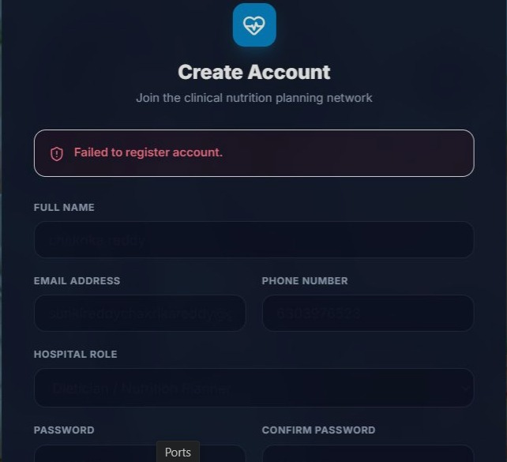
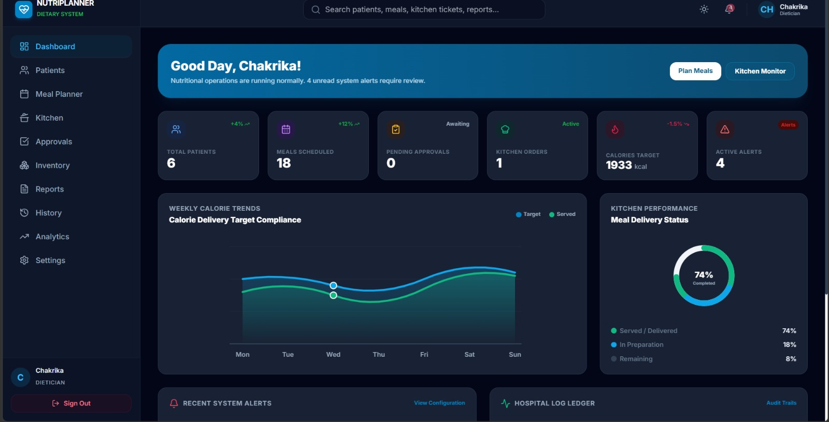

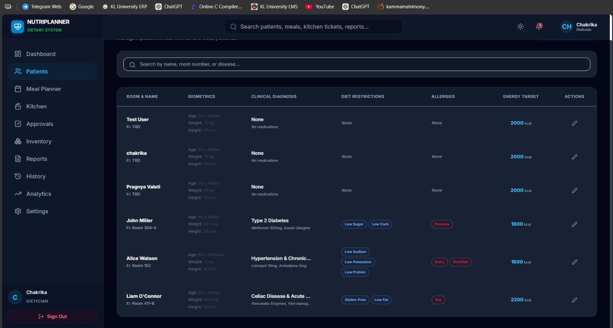
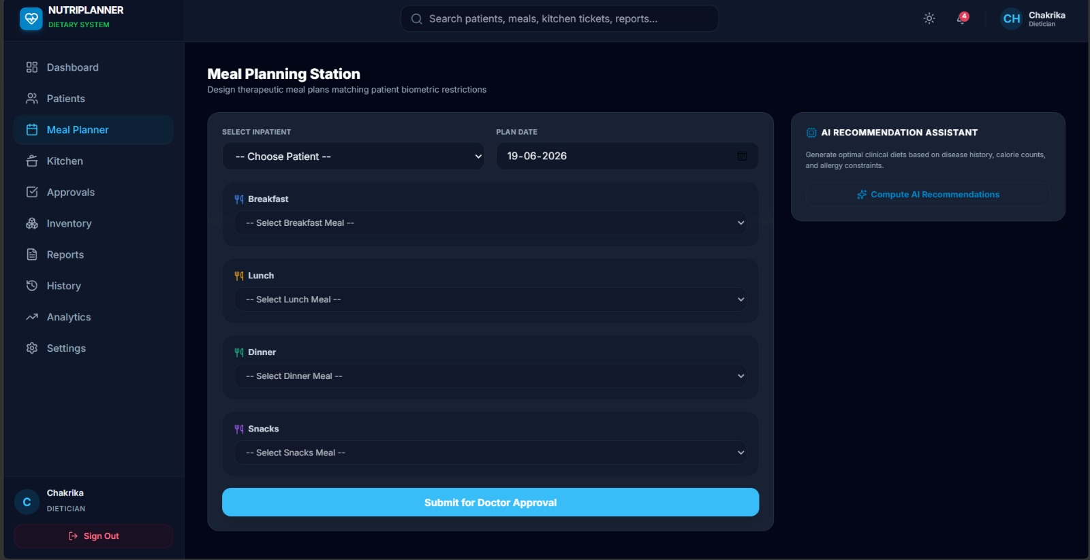

Sample code snippets

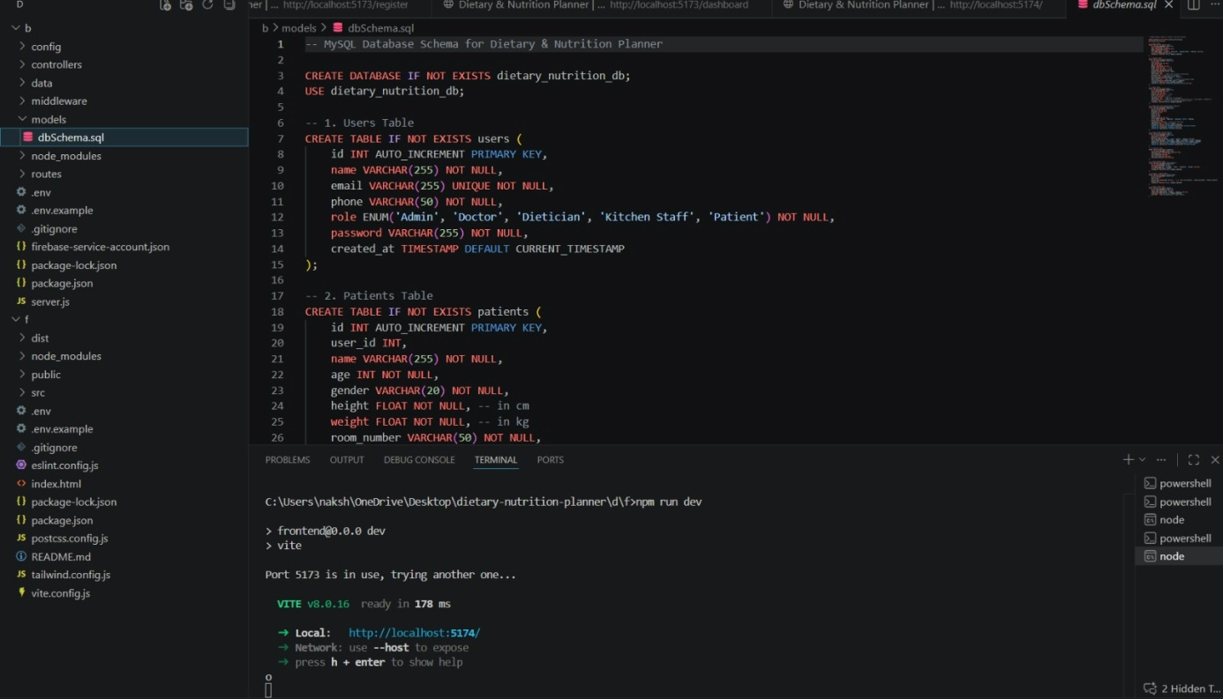
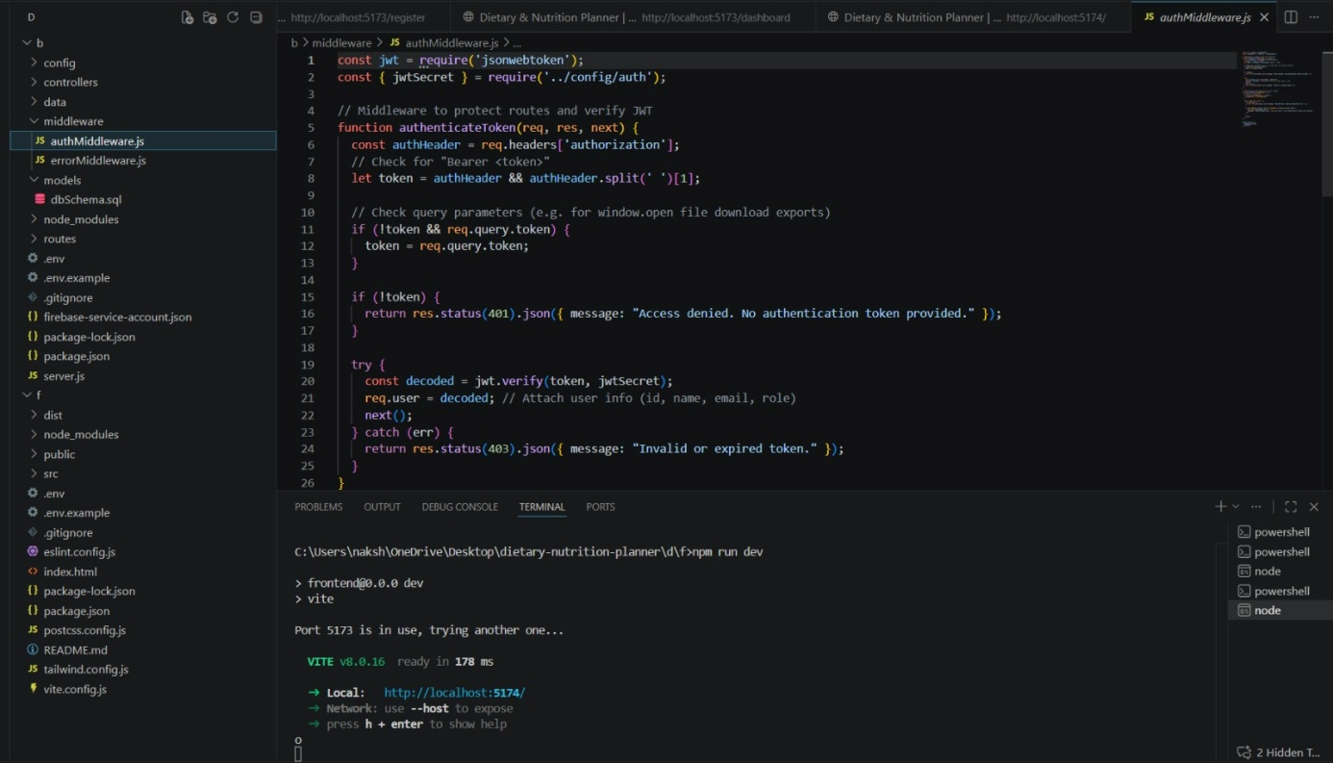

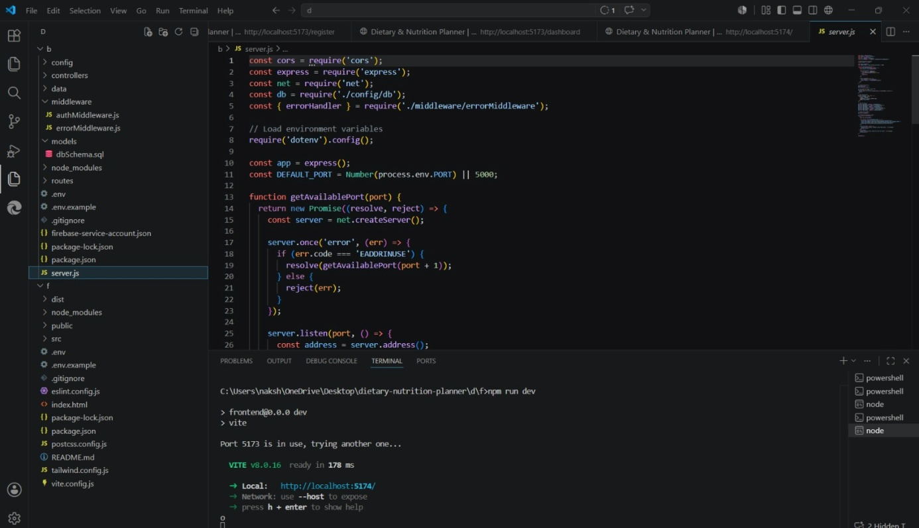

Installation/setup instructions
- The Dietary & Nutrition Planner application detailed in WhatsApp Image 2026-06-30 at 21.13.56 (1).jpeg is developed using React.js with Vite as the development environment, supported by a Node.js and Express.js backend. To set up the project, Node.js (LTS version) must first be installed on the system, as it includes the npm package manager required for installing project dependencies. After downloading the project, open the project folder in Visual Studio Code and execute the npm install command in the terminal. This command installs all the required libraries and packages, including React, Express.js, React Router, Axios, and other dependencies specified in the package.json file. Once the installation is complete, start the application by running the npm run dev command. Vite will launch a local development server and generate a localhost URL (typically http://localhost:5173), which can be opened in any modern web browser to access the application while connecting to the REST APIs and your optional MySQL database instance. The project consists of separate integrated views for the Patient dietary profile, Meal planner, Allergy check, Calorie calc, Kitchen order, Approval flow, History, Export, Notifications, and Admin panel, with Tailwind CSS used for styling and React Router providing smooth navigation between different pages. This setup ensures that the application can be developed, tested, and executed efficiently in a local development environment.

Geo Tag photos with guide


Review forms with guide signatures

